**Software installation and data download for the training entitled “XXX”**

1. **Installation of R and R studio**

**Instructions**

Required software:

* R [go to <https://cran.r-project.org/> ], choose your operating system, select ‘base’, download latest version, double click downloaded .exe file and follow the instruction
* RStudio [go to <https://rstudio.com/products/rstudio/download/> ], download latest RStudio desktop version (free), double click downloaded .exe file and follow the instruction

Please make sure you install the software to the typical software installation directory (For Window this is: C:\Programe Files\) and preferably not in your user profile.

RStudio is in principle the main R scripting environment. Once you start RStudio, it should automatically find and connect to R.

R comes with basic functionality for statistical analysis. For more advanced analysis, including spatial analysis, ‘packages’ need to be installed. For this training, the following packages are used and should be installed prior to the training:

R packages: lubridate, raster, ggplot2, rgdal, rstudioapi, stringr, MODIStsp

Make sure that you have internet connection.

To install R packages in one line, you can copy the following lines to the RStudio console and then press ‘enter’ (copy the three lines in one go).

#installation  
  
list.of.packages <- c("lubridate","ggplot2","rgdal","raster", "stringr","rstudioapi","MODIStsp")  
  
new.packages <- list.of.packages[!(list.of.packages %in%   
 installed.packages()[,"Package"])]   
  
if(length(new.packages)) install.packages(new.packages, dependencies=TRUE)

Testing: Similarly copy following lines to the RStudio console and press ‘enter’ (copy all lines in one go). Warning is fine but you should not get any error.

#Testing

library(lubridate)

library(rgdal)

library(raster)

library(ggplot2)

library(stringr)

library(rstudioapi)

library(MODIStsp

Alternatively, you can also install R package without using code.

For this, open RStudio and click Packages

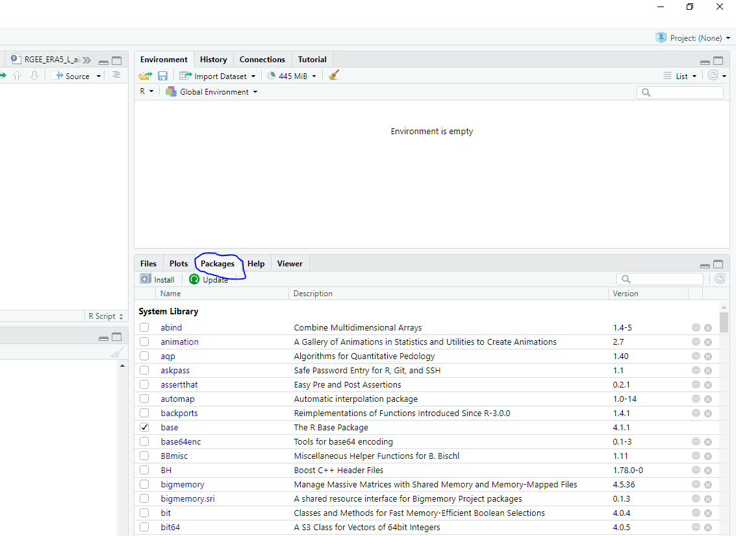

Now click Install, following box will appear.

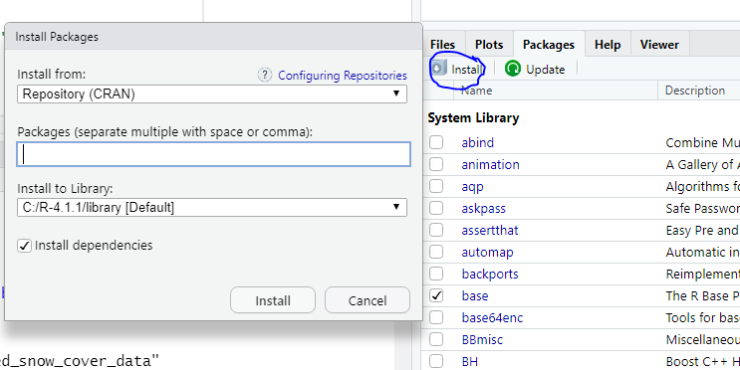

You now need to type the name of each package and click it when it appears in the list. Then click install. It will install the package. Then repeat this process for each package you want to install.

